Installing MySQL.
Name.
Institution.
Date.

Question 1:
During installation, I encountered one great challenge subscribing from System error 1067 that occurred. The errors resulted because of the conflict between recent and old configuration files. As retrieved from my installation practices, I forgot to rename the available old configuration records immediately after enacting a different version of MySQL. However, I then installed another version which helped to address the conflict amid the configuration files.
Question 2:
MySQL is endowed with multiple capabilities as follows;
- Speed – MySQL is a bit faster as compared to other related programs in operation.
- SQL is very compatible – The platform applies standardized language for researching, managing as well as maintaining data updates (Majekodunmi, 2018). MySQL is very flexible in its operations.
- Independence – the platform can operate under different operating systems.
- Multiple programming languages – different APIs can be utilized in MySQL for programming.
- ODBC – the ODBC interface facilitates applicability of many programming languages.
- GIS functions – MySQL supports processing of 2D geographical information hence making it suitable.

Question 3:
The procedure for implementation of the database in MySQL is quite technical and requires complete focus. The procedure would include:
Conceptual phase – the ORM criteria is put into par tice to create the idea.
Logical phase – when undertaking this process, one should restructure the information as outlined in the entire project logically.
Physical phase – the logical model is then carried out (implemented) in actuality at this phase.
MySQL should also be effected about the details of the entire organization. As such, it should capture fundamental data like the number of employees (Sehgal & Bhatt, 2018).
Question 4:
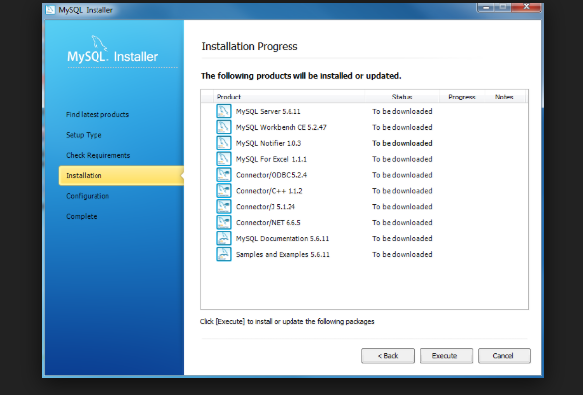
A screenshot of MySQL after installation.
References.
Majekodunmi, D. (2018). Installing ProcesMaker on a Cloud Server. In Business Process Automation with ProcessMaker 3.1 (pp. 419-449). Apress, Berkeley, CA.
Sehgal, N. K., & Bhatt, P. C. P. (2018). Hands-On Project to Use Cloud Service Provider. In Cloud Computing (pp. 195-239). Springer, Cham.

